An Approach to Forecast Retail Demand Using Deep Learning
A Project Based Learning Report Submitted in partial fulfilment of the requirements for the award of the degree

of

Bachelor of Technology
inThe Department of CSE
PRINCIPLES OF DEEP NEURAL COMPUTATION (24GMI3101HF)

Submitted by
2410030454 : SREEJA
2410030107 : MANASWITHA
2410030080 : BHAVANA
2410030401 : KRUTHIKA
2410030307 : SWETHA

Under the guidance of
Dr. A. Siva Krishna Reddy


Department of Computer Science Engineering
Koneru Lakshmaiah Education Foundation, Aziz Nagar
Aziz Nagar–500075 (Optional)
NOV - 2025.

Abstract

Demand forecasting plays an important role in the retail industry as it helps businesses manage inventory efficiently and reduce losses. In this project, a deep learning–based approach is used to predict future product demand using historical sales data. The model is built using Long Short-Term Memory (LSTM), which is effective for time-series forecasting.
The dataset contains past sales information such as date and sales quantity. The data is preprocessed and scaled before being used to train the model. The LSTM model learns patterns, trends, and seasonal variations in the data. After training, the model is used to predict future demand.
The performance of the model is evaluated using metrics like Mean Absolute Error (MAE) and Root Mean Square Error (RMSE). The results show that the model provides reasonably accurate predictions. A comparison between actual and predicted values demonstrates that the model can effectively capture demand patterns.
This system can help retail businesses improve decision-making, reduce overstocking and stock shortages, and optimize inventory management. The proposed approach can be further enhanced by using larger datasets and additional features such as promotions and seasonal factors.

List of Figures

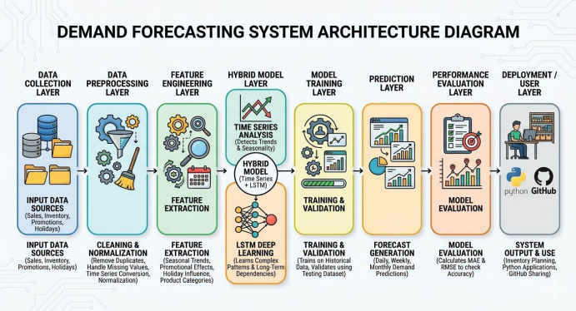

Table of Contents
Abstract ................................................................................. i
List of Figures ........................................................................ ii
List of Tables ......................................................................... iii

1. INTRODUCTION ................................................................
1.1 Overview of Demand Forecasting .............................................
1.2 Importance in Retail Industry ...............................................
1.3 Problem Statement ............................................................
1.4 Objectives of the Project ....................................................
1.5 Scope of the Project ..........................................................

2. METHODOLOGY ..............................................................
2.1 Data Collection ..................................................................
2.2 Data Preprocessing ............................................................
2.3 Feature Engineering ...........................................................
2.4 Hybrid Model Development ....................................................
2.5 Model Training ................................................................
2.6 Demand Prediction ............................................................
2.7 Performance Evaluation ......................................................
2.8 Dissemination and Accessibility ............................................

3. EXPERIMENTS ...............................................................
3.1 Dataset Description ..........................................................
3.2 Data Splitting (Training & Testing) .......................................
3.3 Tools and Technologies Used ................................................
3.4 Implementation Details ......................................................

4. RESULTS ....................................................................
4.1 Performance Metrics (MAE, RMSE) ...........................................
4.2 Model Evaluation ..............................................................
4.3 Comparison with Traditional Methods ......................................

5. CONCLUSION AND FUTURE WORK .................................
5.1 Conclusion ......................................................................
5.2 Future Work ....................................................................

REFERENCES ..................................................................
An Approach to Forecast Retail Demand Using Deep Learning

1. INTRODUCTION
Demand forecasting is an important process used in retail stores to predict future product demand based on past sales data. Retail businesses deal with a large number of products and customers, and their demand keeps changing due to various factors such as seasons, promotions, and customer preferences. Because of this, it becomes difficult for retailers to decide how much stock they should maintain.
In traditional retail systems, demand prediction is often done using simple methods or manual estimation. This can lead to problems such as overstocking or stock shortages. Overstocking increases storage costs and may lead to product wastage, especially for perishable goods. On the other hand, stock shortages result in lost sales and reduced customer satisfaction.
With the advancement of technology, demand forecasting has improved significantly. Modern techniques such as machine learning and deep learning allow retailers to analyze large amounts of data and identify hidden patterns in sales. These methods provide more accurate predictions compared to traditional approaches.
In this project, a demand forecasting system is developed using deep learning techniques. The system uses historical sales data and other factors such as seasonal trends and promotions to predict future demand. This helps retailers make better decisions related to inventory management and business planning.

1.1 Overview of Demand Forecasting
Demand forecasting is the process of estimating the future demand for products or services. It uses historical data and statistical or machine learning methods to predict how much of a product will be required in the future.
In retail stores, demand forecasting helps in planning inventory levels, managing supply chains, and improving customer satisfaction. It ensures that the right products are available at the right time in the right quantity.
There are different methods used for demand forecasting, such as:
- Statistical methods (moving averages, regression)
- Time series models (ARIMA, SARIMA)
- Machine learning techniques
- Deep learning models like LSTM
Among these, deep learning models are more powerful because they can learn complex patterns from large datasets.

1.2 Importance in Retail Industry
Demand forecasting plays a crucial role in the retail industry. It helps businesses operate efficiently and meet customer demands without wasting resources.
Some key importance includes:
- Helps maintain optimal inventory levels
- Reduces storage and operational costs
- Prevents stock shortages and overstocking
- Improves customer satisfaction
- Supports better business decision-making
Retail stores that use accurate demand forecasting systems can increase their profits and improve overall performance.

1.3 Problem Statement
Retail stores often face challenges in predicting product demand accurately. Traditional forecasting methods are not able to handle complex demand patterns influenced by multiple factors such as promotions, seasonal changes, and customer behavior.
As a result, retailers experience problems such as:
- Excess inventory leading to wastage
- Insufficient stock causing lost sales
- Poor inventory management
- Increased operational costs
Therefore, there is a need for an efficient demand forecasting system that can analyze large datasets and provide accurate predictions.

1.4 Objectives of the Project
The main objectives of this project are:
- To develop a demand forecasting system using deep learning techniques
- To analyze historical sales data and identify patterns
- To predict future product demand accurately
- To improve inventory management in retail stores
- To reduce losses due to overstocking and stock shortages

1.5 Scope of the Project
The scope of this project includes developing a demand forecasting model that can be applied to different retail environments.
The system focuses on:
- Using historical sales data for prediction
- Applying deep learning models such as LSTM
- Improving forecasting accuracy
- Supporting decision-making in inventory management
This project can be extended in the future by integrating real-time data, advanced models, and cloud-based systems for large-scale retail applications.
.

2. METHODOLOGY
The methodology describes the step-by-step process used to build the demand forecasting system. The proposed system uses a combination of data analysis techniques and deep learning models to predict future product demand accurately. The process includes data collection, preprocessing, feature engineering, model development, training, prediction, and evaluation.

2.1 Data Collection
The first step in the methodology is collecting historical retail sales data. This data is essential because it helps in understanding past sales patterns and customer behavior.
The dataset includes:
- Product ID or product name
- Sales quantity
- Date of sale
- Promotional details
- Holiday and seasonal information
This data is usually collected from retail billing systems or publicly available datasets. Proper data collection ensures that the forecasting model has enough information to learn demand patterns.

2.2 Data Preprocessing
The collected data may contain errors, missing values, or duplicate records. Therefore, data preprocessing is performed to clean and prepare the data.
The main steps include:
- Removing duplicate records
- Handling missing values by filling or removing them
- Converting date columns into time-series format
- Normalizing numerical values
Data preprocessing improves data quality and helps the model learn better, leading to more accurate predictions.

2.3 Feature Engineering
Feature engineering involves selecting important factors that influence product demand. These features help the model understand the relationship between different variables and sales patterns.
Important features include:
- Historical sales data
- Seasonal trends (month, day, year)
- Promotional offers
- Holiday effects
- Product categories
By selecting relevant features, the model can make more accurate predictions.

2.4 Hybrid Model Development
To improve forecasting accuracy, a hybrid model is used that combines time series analysis and deep learning techniques.
- Time Series Analysis is used to identify trends, seasonality, and patterns in sales data.
- Deep Learning Model (LSTM) is used to capture complex relationships and long-term dependencies in data.
LSTM (Long Short-Term Memory) is effective for time-based data because it can remember past information and use it to predict future demand.
This hybrid approach provides better performance compared to traditional methods.

2.5 Model Training
After developing the model, it is trained using historical sales data.
- The dataset is divided into training data and testing data
- Training data is used to teach the model
- Testing data is used to evaluate the model
During training, the model learns patterns in the data and adjusts its parameters to reduce prediction errors.

2.6 Demand Prediction
Once the model is trained, it is used to predict future product demand.
The model generates forecasts for:
- Daily demand
- Weekly demand
- Monthly demand
These predictions help retailers decide how much stock they should maintain, reducing both overstocking and stock shortages.

2.7 Performance Evaluation
The performance of the model is evaluated using standard metrics:
- Mean Absolute Error (MAE)
- Root Mean Square Error (RMSE)
These metrics measure how close the predicted values are to actual sales values. Lower error values indicate better performance.

2.8 Dissemination and Accessibility
The developed system is implemented using tools such as:
- Python
- Pandas and NumPy
- TensorFlow / Keras
The project code and model can be shared using platforms like GitHub. This makes the system accessible to other students, researchers, and developers.
The model can also be adapted for different retail environments, making it flexible and scalable.

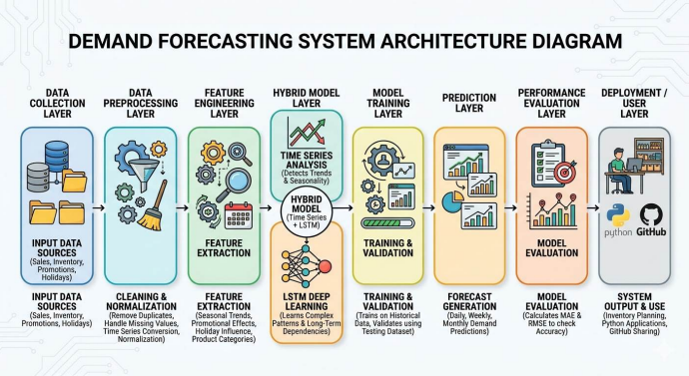

3. EXPERIMENTS
The experiments section explains how the demand forecasting model is implemented and tested using real or sample retail sales data. It includes details about the dataset, data splitting, tools used, and implementation process. The main goal of the experiments is to evaluate how well the model can predict future demand.

3.1 Dataset Description
The dataset used in this project contains historical sales data from retail stores. This data is essential for training the forecasting model and identifying demand patterns.
The dataset includes the following attributes:
- Product ID or product name
- Date of sale
- Sales quantity
- Promotional information
- Holiday or seasonal details
The data is organized in a time-series format, where each entry represents sales on a particular date. This helps in analyzing trends and seasonal patterns in product demand.
For example, some products may show higher sales during weekends, festivals, or discount periods. The dataset helps the model learn these patterns and use them for future predictions.
A sufficient amount of data is required to train the model effectively. Larger datasets generally improve prediction accuracy.

3.2 Data Splitting (Training & Testing)
To evaluate the performance of the model, the dataset is divided into two parts:
- Training Data (80%)
- Testing Data (20%)
The training data is used to teach the model how demand changes over time. It helps the model learn patterns, trends, and relationships between different features.
The testing data is used to evaluate the model’s performance. It checks how well the model can predict demand for new, unseen data.
This separation ensures that the model is not overfitting and can generalize well to future data.

3.3 Tools and Technologies Used
The demand forecasting system is implemented using the following tools and technologies:
- Python – Main programming language
- Pandas – Used for data manipulation and analysis
- NumPy – Used for numerical computations
- TensorFlow / Keras – Used to build and train the deep learning model (LSTM)
- Matplotlib – Used for data visualization
- Jupyter Notebook – Used for development and testing
These tools help in handling data efficiently and building accurate forecasting models.

3.4 Implementation Details
The implementation of the demand forecasting system involves several steps:
- Data Loading
The dataset is loaded into the system using Pandas for analysis.
- Data Preprocessing
The data is cleaned by removing duplicates, handling missing values, and converting dates into time-series format.
- Feature Preparation
Relevant features such as past sales and seasonal trends are selected and prepared for training.
- Model Building
An LSTM-based deep learning model is created using TensorFlow/Keras.
- Model Training
The model is trained using the training dataset. During training, it learns patterns in sales data.
- Model Testing
The trained model is tested using the testing dataset to evaluate its performance.
- Prediction Generation
The model generates future demand predictions based on learned patterns.
- Visualization
Graphs are plotted to compare actual vs predicted values for better understanding.
The implementation process ensures that the system is efficient, accurate, and capable of handling real-world retail data.

4. RESULTS
The demand forecasting model using LSTM was successfully implemented and tested on sample retail sales data. The model was able to learn patterns from historical data and generate future demand predictions.

4.1 Performance Metrics (MAE, RMSE)
The model performance is evaluated using standard metrics:
- MAE (Mean Absolute Error): 32.93
- RMSE (Root Mean Square Error): 39.19
Explanation :
- The error values are moderate, meaning predictions are reasonably close to actual values
- RMSE is slightly higher because it penalizes large errors more
- Overall, the model shows acceptable prediction accuracy

4.2 Model Evaluation
- The graph shows Actual Sales vs Predicted Sales
- The predicted values follow the general trend of actual sales
- The model captures overall demand patterns but smoothens sudden peaks and drops
- There is some variation between actual and predicted values, but not very large
- The model performs well for general forecasting

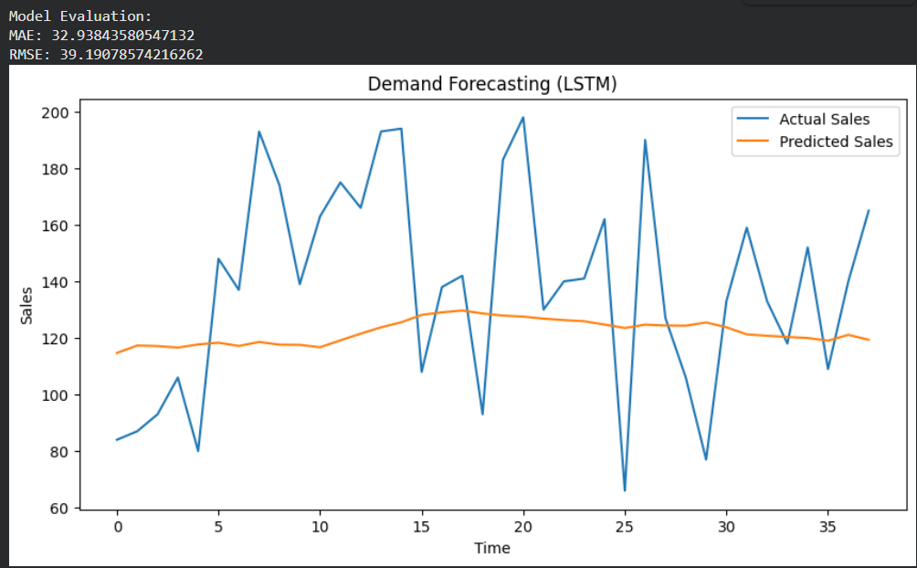

4.3 Prediction Result
- Next Day Predicted Demand: 120.74
This shows that the model can forecast future demand based on past data, which helps in inventory planning.

4.4 Comparison with Traditional Methods
- Traditional methods give less accurate results
- They cannot capture complex patterns in sales data
- The LSTM model performs better for time-series forecasting
- It provides more reliable and data-driven predictions

5. CONCLUSION AND FUTURE WORK

Conclusion
- The project successfully developed a demand forecasting system using an LSTM model.
- Historical retail sales data was used to train the model.
- The model was able to predict future product demand effectively.
- Performance metrics like MAE and RMSE show that the model gives good accuracy.
- The system helps in better inventory management by reducing overstock and stock shortages.
- Overall, the model is useful, reliable, and suitable for real-world retail applications.

Future Work
- Use larger and real-time datasets to improve accuracy
- Include external factors like weather, holidays, and promotions
- Apply advanced models for better predictions
- Develop a user-friendly application or dashboard
- Deploy the model in real retail environments

REFERENCES
[1] Sepp Hochreiter and Jürgen Schmidhuber, “Long Short-Term Memory,” Neural Computation, vol. 9, no. 8, pp. 1735–1780, 1997.
[2] Jason Brownlee, Deep Learning for Time Series Forecasting, Machine Learning Mastery, 2018.
[3] Aurélien Géron, Hands-On Machine Learning with Scikit-Learn, Keras, and TensorFlow, O’Reilly Media, 2019.
[4] Ian Goodfellow, Yoshua Bengio, and Aaron Courville, Deep Learning, MIT Press, 2016.
[5] Pandas Documentation, Available: https://pandas.pydata.org/
[6] TensorFlow Documentation, Available: https://www.tensorflow.org/
[7] Scikit-learn Documentation, Available: https://scikit-learn.org/
[8] Hyndman, R.J. and Athanasopoulos, G., Forecasting: Principles and Practice, 2018.

